Coronavirus disease 2019 (COVID-19)
Situation Report – 39

Data as reported by 10AM CET 28 February 2020
HIGHLIGHTS

- Five new Member States (Belarus, Lithuania, Netherlands, New Zealand, and Nigeria) reported cases of COVID-19 in the past 24 hours.
- WHO has increased the assessment of the risk of spread and risk of impact of COVID-19 to very high at the global level. More information can be found here.
- The WHO-China Joint Mission, which was conducted from 16 through 24 February, has published its findings. The full report can be found here.
- WHO has updated the guidance on Global Surveillance for human infection with coronavirus disease (COVID-19). This document includes revised surveillance case definitions for COVID-19. It is also accompanied by a revised Case Reporting Form, line listing template, and data dictionary.
- Table 2 in this Situation Report, “Countries, territories or areas outside China with reported laboratory-confirmed COVID-19 cases and deaths”, has been simplified and now includes transmission classification. See Table 2 footnotes for additional information.
- As of 27 February, there are 36 117 (26 403 in Hubei and 15 826 in Wuhan) cases who have recovered from COVID-19 in China.
- Under the International Health Regulations (2005), States Parties implementing additional health measures that significantly interfere with international traffic shall notify WHO of the public health rationale of those measures within 48 hours of their implementation. As of 27 February, 41 States Parties are officially reporting additional health measures. More information can be found in the Subject in Focus.

SITUATION IN NUMBERS
total and new cases in last 24 hours

Globally
83 652 confirmed (1358 new)

China
78 961 confirmed (331 new)
2791 deaths (44 new)

Outside of China
4691 confirmed (1027 new)
51 countries (5 new)
67 deaths (10 new)

WHO RISK ASSESSMENT
China | Very High
Regional Level | Very High
Global Level | Very High

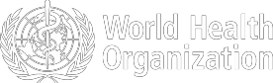

Figure 1. Countries, territories or areas with reported confirmed cases of COVID-19, 28 February 2020
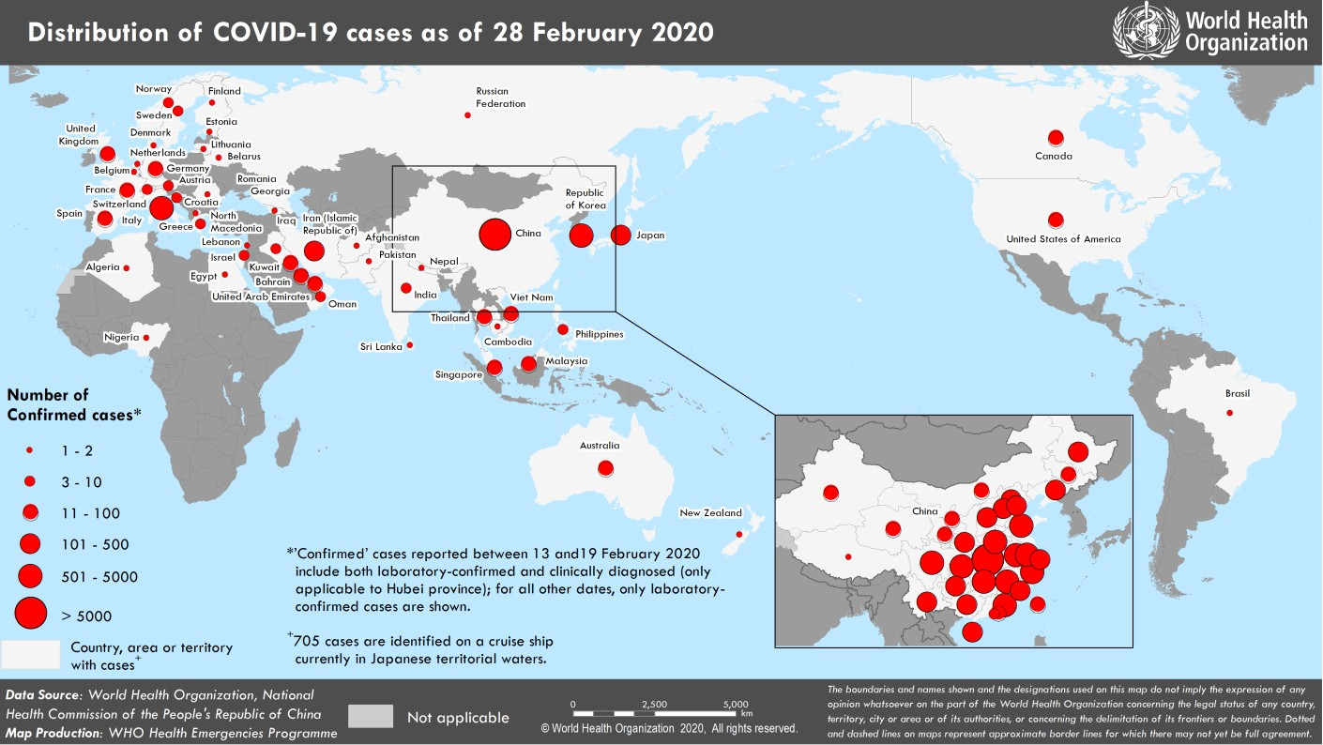

SUBJECT IN FOCUS: UPDATE ON ADDITIONAL HEALTH MEASURES

As of 27 February 2020, 41 States Parties have provided to WHO official reports on additional health measures that significantly interfere with international traffic under Article 43 of the International Health Regulations (2005), of which 14 are small island developing states. Seven States Parties provided updates on the measures they have previously reported on. Eleven of the 41 States Parties are now reporting such measures against countries other than China. No trade restrictions have been reported to date. Table 1 presents a summary of additional health measures officially reported to WHO under Article 43 from 6 – 28 February, by WHO region.

Table 1. Number of States Parties officially reporting additional health measures that significantly interfere with international traffic (i.e. more than 24h delay), under Article 43 of the IHR (2005) (by WHO region)
WHO Region | Date States Parties provided to WHO official reports on additional health measures |  |  |  | Total
WHO Region | 6 Feb | 12 Feb | 20 Feb | 28 Feb | Total
AMRO-PAHO | 10 | 2 | 0 | 0 | 12
AFRO | 0 | 1 | 0 | 0 | 1
EMRO | 0 | 1 | 0 | 1 | 2
EURO | 2 | 1 | 2 | 5 | 10
SEARO | 1 | 0 | 0 | 0 | 1
WPRO | 9 | 3 | 2 | 1 | 15
Total | 22 | 8 | 4 | 7 | 41

The majority of these measures are related to denial of entry of travelers originating from China or from countries reporting on-going transmission of COVID-19, quarantine requirements for foreigners, self-isolation of returning nationals, and visa restrictions. The public health rationale for these additional health measures is mainly linked to vulnerabilities (e.g. lack of capacity for diagnostic and response, small island states context) in receiving countries, and the uncertainties about the virus transmission and disease severity.

Preliminary analysis of countries reporting cases that have imposed restrictive measures suggest that such measures may have delayed the importation of new cases, but did not prevent the importation of the disease. WHO has emphasized to Member States that additional measures should be proportionate to the public health risk, short in duration, and reconsidered in light of the evolution of the outbreak and the constant advancements of knowledge about the virus and the disease.

WHO has published updated advice for international traffic, and continues to recommend against the application of any travel or trade restrictions in relation to the current COVID-19 outbreak.

WHO continues to engage with travel and tourism international organizations and industry associations to enable compliance with the IHR on avoidance of unnecessary interference with international traffic. Joint statements have been issued by WHO in collaboration with the International Maritime Organization (IMO), and UN World Tourism Organization (UNWTO), and will shortly be issues in collaboration with the International Civil Aviation Organization (ICAO).
SURVEILLANCE

Table 1. Confirmed and suspected cases of COVID-19 acute respiratory disease reported by provinces, regions and cities in China, Data as of 28 February 2020
Province/ Region/ | Population (10,000s) | Confirmed | Daily  Suspected |  | Cumulative  Confirmed
City | cases |  | cases | Deaths | cases |  | Deaths
Hubei | 5917 | 318 | 332 | 41 | 65914 |  | 2682
Guangdong | 11346 | 1 | 2 | 0 | 1348 |  | 7
Henan | 9605 | 0 | 1 | 0 | 1272 |  | 20
Zhejiang | 5737 | 0 | 0 | 0 | 1205 |  | 1
Hunan | 6899 | 0 | 0 | 0 | 1017 |  | 4
Anhui | 6324 | 1 | 0 | 0 | 990 |  | 6
Jiangxi | 4648 | 1 | 0 | 0 | 935 |  | 1
Shandong | 10047 | 0 | 0 | 0 | 756 |  | 6
Jiangsu | 8051 | 0 | 0 | 0 | 631 |  | 0
Chongqing | 3102 | 0 | 6 | 0 | 576 |  | 6
Sichuan | 8341 | 4 | 4 | 0 | 538 |  | 3
Heilongjiang | 3773 | 0 | 0 | 0 | 480 |  | 13
Beijing | 2154 | 0 | 12 | 2 | 410 |  | 7
Shanghai | 2424 | 0 | 36 | 0 | 337 |  | 3
Hebei | 7556 | 1 | 0 | 0 | 318 |  | 6
Fujian | 3941 | 0 | 0 | 0 | 296 |  | 1
Guangxi | 4926 | 0 | 0 | 0 | 252 |  | 2
Shaanxi | 3864 | 0 | 0 | 0 | 245 |  | 1
Yunnan | 4830 | 0 | 4 | 0 | 174 |  | 2
Hainan | 934 | 0 | 5 | 0 | 168 |  | 5
Guizhou | 3600 | 0 | 1 | 0 | 146 |  | 2
Tianjin | 1560 | 1 | 24 | 0 | 136 |  | 3
Shanxi | 3718 | 0 | 0 | 0 | 133 |  | 0
Liaoning | 4359 | 0 | 22 | 0 | 121 |  | 1
Jilin | 2704 | 0 | 3 | 0 | 93 |  | 1
Hong Kong SAR | 745 | 2 | 0 | 0 | 93 |  | 2
Gansu | 2637 | 0 | 0 | 0 | 91 |  | 2
Xinjiang | 2487 | 0 | 0 | 1 | 76 |  | 3
Inner Mongolia | 2534 | 0 | 0 | 0 | 75 |  | 0
Ningxia | 688 | 0 | 0 | 0 | 72 |  | 0
Taipei and environs | 2359 | 2 | 0 | 0 | 34 |  | 1
Qinghai | 603 | 0 | 0 | 0 | 18 |  | 0
Macao SAR | 66 | 0 | 0 | 0 | 10 |  | 0
Xizang | 344 | 0 | 0 | 0 | 1 |  | 0
Total | 142823 | 331 | 452 | 44 | 78961 |  | 2791

Table 2. Countries, territories or areas outside China with reported laboratory-confirmed COVID-19 cases and deaths. Data as of 28 February 2020
Country | Total confirmed* cases (new) | Total deaths (new) | Transmission classification† | Days since last reported case
Western Pacific Region
Republic of Korea | 2337 (571) | 13 (0) | Local transmission | 0
Japan | 210 (24) | 4 (1) | Local transmission | 0
Singapore | 96 (3) | 0 (0) | Local transmission | 0
Malaysia | 24 (2) | 0 (0) | Local transmission | 0
Australia | 23 (0) | 0 (0) | Local transmission | 3
Viet Nam | 16 (0) | 0 (0) | Local transmission | 15
Philippines | 3 (0) | 1 (0) | Imported cases only | 24
Cambodia | 1 (0) | 0 (0) | Imported cases only | 32
New Zealand | 1 (1) | 0 (0) | Imported cases only | 0
European Region
Italy | 650 (250) | 17 (5) | Local transmission | 0
France | 38 (20) | 2 (0) | Local transmission | 0
Germany | 26 (5) | 0 (0) | Local transmission | 0
Spain | 25 (13) | 0 (0) | Local transmission | 0
The United Kingdom | 16 (3) | 0 (0) | Local transmission | 0
Sweden | 7 (5) | 0 (0) | Imported cases only | 0
Switzerland | 6 (5) | 0 (0) | Imported cases only | 0
Austria | 4 (2) | 0 (0) | Imported cases only | 0
Norway | 4 (3) | 0 (0) | Imported cases only | 0
Greece | 3 (2) | 0 (0) | Imported cases only | 0
Israel | 3 (1) | 0 (0) | Imported cases only | 0
Croatia | 3 (0) | 0 (0) | Local transmission | 0
Finland | 2 (0) | 0 (0) | Imported cases only | 2
Russian Federation | 2 (0) | 0 (0) | Imported cases only | 28
Belarus | 1 (1) | 0 (0) | Imported cases only | 0
Lithuania | 1 (1) | 0 (0) | Imported cases only | 0
Netherlands | 1 (1) | 0 (0) | Imported cases only | 0
North Macedonia | 1 (0) | 0 (0) | Imported cases only | 2
Romania | 1 (0) | 0 (0) | Imported cases only | 1
Belgium | 1 (0) | 0 (0) | Imported cases only | 24
Denmark | 1 (0) | 0 (0) | Imported cases only | 1
Estonia | 1 (0) | 0 (0) | Imported cases only | 1
Georgia | 1 (0) | 0 (0) | Imported cases only | 1
South-East Asia Region
Thailand | 40 (0) | 0 (0) | Local transmission | 2
India | 3 (0) | 0 (0) | Imported cases only | 25
Nepal | 1 (0) | 0 (0) | Imported cases only | 46
Sri Lanka | 1 (0) | 0 (0) | Imported cases only | 32
Eastern Mediterranean Region
Iran (Islamic Republic of) | 245 (104) | 26 (4) | Local transmission | 0
Kuwait | 43 (0) | 0 (0) | Imported cases only | 1
Bahrain | 33 (0) | 0 (0) | Imported cases only | 1
United Arab Emirates | 19 (6) | 0 (0) | Local transmission | 0
Iraq | 7 (1) | 0 (0) | Imported cases only | 0
Oman | 6 (2) | 0 (0) | Imported cases only | 0
Lebanon | 2 (0) | 0 (0) | Imported cases only | 2
Pakistan | 2 (0) | 0 (0) | Imported cases only | 2
Afghanistan | 1 (0) | 0 (0) | Imported cases only | 4

Egypt | 1 (0) | 0 (0) | Imported cases only | 14
Region of the Americas
United States of America | 59 (0) | 0 (0) | Local transmission | 2
Canada | 11 (0) | 0 (0) | Imported cases only | 2
Brazil | 1 (0) | 0 (0) | Imported cases only | 2
African Region
Algeria | 1 (0) | 0 (0) | Imported cases only | 3
Nigeria | 1 (1) | 0 (0) | Imported cases only | 0
Subtotal for all regions | 3986 (1027) | 63 (10)
International conveyance (Diamond Princess) ‡ | 705 (0) | 4 (0) | Local transmission | 2
Grand total§ | 4691 (1027) | 67 (10)
*Case classifications are based on WHO case definitions for COVID-19.
†Transmission classification is based on WHO analysis of available official data and may be subject to reclassification as additional data become available. Countries/territories/areas experiencing multiple types of transmission are classified in the highest category for which there is evidence; they may be removed from a given category if interruption of transmission can be demonstrated. It should be noted that even within categories, different countries/territories/areas may have differing degrees of transmission as indicated by the differing numbers of cases and other factors. Not all locations within a given country/territory/area are equally affected.
Terms:
- Community transmission is evidenced by the inability to relate confirmed cases through chains of transmission for a large number of cases, or by increasing positive tests through routine screening of sentinel samples.
- Local transmission indicates locations where the source of infection is within the reporting location.
- Imported cases only indicates locations where all cases have been acquired outside the location of reporting.
- Under investigation indicates locations where type of transmission has not been determined for any cases.
- Interrupted transmission indicates locations where interruption of transmission has been demonstrated (details to be determined)
‡Cases identified on a cruise ship currently in Japanese territorial waters.
§250 female/363 male/4078 unknown. 28 healthcare workers (5 female/12 male/ 11 unknown)
Corrigendum: Values under ‘Days since last reported case’ have been updated to reflect time of reporting within a given day

Figure 2. Epidemic curve of confirmed COVID-19 cases (n=4072) reported outside of China, by date of report and WHO region with complete days of reporting through 27 February 2020

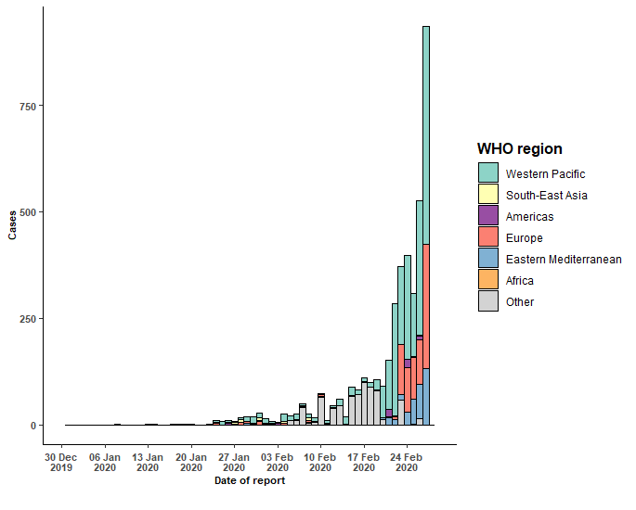
STRATEGIC OBJECTIVES

WHO’s strategic objectives for this response are to:

  - Interrupt human-to-human transmission including reducing secondary infections among close contacts and health care workers, preventing transmission amplification events, and preventing further international spread*;
  - Identify, isolate and care for patients early, including providing optimized care for infected patients;
  - Identify and reduce transmission from the animal source;
  - Address crucial unknowns regarding clinical severity, extent of transmission and infection, treatment options, and accelerate the development of diagnostics, therapeutics and vaccines;
  - Communicate critical risk and event information to all communities and counter misinformation;
  - Minimize social and economic impact through multisectoral partnerships.

*This can be achieved through a combination of public health measures, such as rapid identification, diagnosis and management of the cases, identification and follow up of the contacts, infection prevention and control in health care settings, implementation of health measures for travelers, awareness-raising in the population and risk communication.

PREPAREDNESS AND RESPONSE

- To view all technical guidance documents regarding COVID-19, please go to this webpage.
- WHO is working closely with International Air Transport Association (IATA) and have jointly developed a guidance document to provide advice to cabin crew and airport workers, based on country queries. The guidance can be found on the IATA webpage.
- WHO has been in regular and direct contact with Member States where cases have been reported. WHO is also informing other countries about the situation and providing support as requested.
- WHO has developed interim guidance for laboratory diagnosis, advice on the use of masks during home care and in health care settings in the context of the novel coronavirus (2019-nCoV) outbreak, clinical management, infection prevention and control in health care settings, home care for patients with suspected novel coronavirus, risk communication and community engagement and Global Surveillance for human infection with novel coronavirus (2019-nCoV).
- WHO is working with its networks of researchers and other experts to coordinate global work on surveillance, epidemiology, modelling, diagnostics, clinical care and treatment, and other ways to identify, manage the disease and interrupt onward transmission. WHO has issued interim guidance for countries, which are updated regularly.
- WHO is working with global expert networks and partnerships for laboratory, infection prevention and control, clinical management and mathematical modelling.
- WHO has prepared disease commodity package that includes an essential list of biomedical equipment, medicines and supplies necessary to care for patients with 2019-nCoV.
- WHO has provided recommendations to reduce risk of transmission from animals to humans.
- WHO has published an updated advice for international traffic in relation to the outbreak of the novel coronavirus 2019-nCoV.
- WHO has activated of R&D blueprint to accelerate diagnostics, vaccines, and therapeutics.
- WHO has developed online courses on the following topics: A general introduction to emerging respiratory viruses, including novel coronaviruses (available in French, Chinese, Spanish, and Portuguese); Critical Care of Severe Acute Respiratory Infections; and Health and safety briefing for respiratory diseases - ePROTECT
(available in French); Infection Prevention and Control for Novel Coronavirus (COVID-19); Critical Care Severe Acute Respiratory Infection
- WHO is providing guidance on early investigations, which are critical to carry out early in an outbreak of a new virus. The data collected from the protocols can be used to refine recommendations for surveillance and case definitions, to characterize the key epidemiological transmission features of COVID-19, help understand spread, severity, spectrum of disease, impact on the community and to inform operational models for implementation of countermeasures such as case isolation, contact tracing and isolation. Several protocols are available here: https://www.who.int/emergencies/diseases/novel-coronavirus-2019/technical-guidance/early-investigations One such protocol is for the investigation of early COVID-19 cases and contacts (the “First Few X (FFX) Cases and contact investigation protocol for 2019-novel coronavirus (2019-nCoV) infection”). The protocol is designed to gain an early understanding of the key clinical, epidemiological and virological characteristics of the first cases of COVID-19 infection detected in any individual country, to inform the development and updating of public health guidance to manage cases and reduce potential spread and impact of infection.

RECOMMENDATIONS AND ADVICE FOR THE PUBLIC

If you are not in an area where COVID-19 is spreading, or if you have not travelled from one of those areas or have not been in close contact with someone who has and is feeling unwell, your chances of being infected are low. It is understandable that you may feel stressed and anxious about the outbreak. It’s a good idea to get the facts from reliable sources to help you accurately determine your risks so that you can take reasonable precautions. (See Frequently Asked Questions). Seek guidance from WHO, your healthcare provider, your national public health authority and your employer on accurate information on COVID-19 and whether COVID-19 is circulating where you live. It is important to be informed of the situation and take appropriate measures to protect yourself and your family (see Protection measures for everyone).

If you are in an area where there is an outbreak of COVID-19 you need to take the risk of infection seriously. Follow the advice of WHO and guidance issued by national and local health authorities. Although for most people COVID-19 infected will cause mild illness, it can make some people very ill and in some people it can be fatal. Older people, and those with pre-existing medical conditions (such as cardiovascular disease, chronic respiratory disease or diabetes) appear to be at risk for severe disease (See Protection measures for persons who are in or have recently visited (past 14 days) areas where COVID-19 is spreading).

